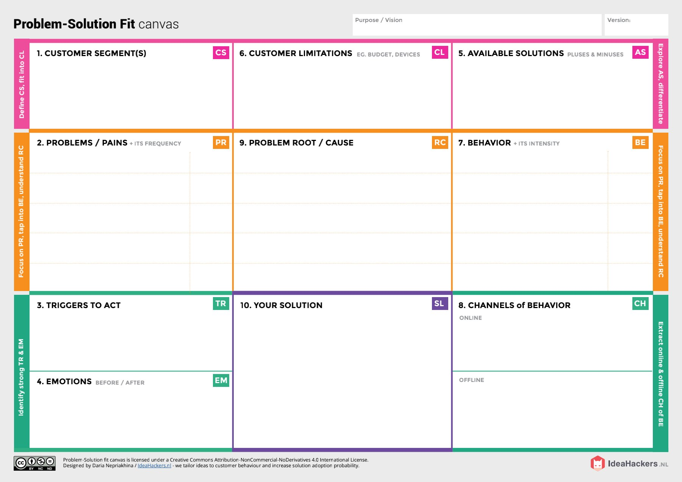

* **Asking suggestions from surrounding peoples and implementing the recent technologies**
* **Searching an alternative solution from an already existing solution.**
* **Hearing about innovative technologies and effective solutions**.
* **Seeing others having better results while following this nutrition chart make better option while compared to other solutions**
* **Lack of knowledge among people regarding the proper amount of nutrition intake.**
* **Many suggestions for a single diet make it hard to concentrate on following a particular routine**
* **People think the only way to get good body shape is to take in artificial supplements**
* **Lack of guidance can cause wrong amount of intake in nutrition and can cause various health issues**
* **Using different platforms /social media to describe uses of the nutrition analyser and how it works as a great tool for fitness enthusiasts.**
* **Gives awareness among people about the types of nutrition intake and how the application is useful for various people who is interested in maintaining**

**Body fitness**

* **improper diet leads to various health related issues.**
* **Muscular atrophy can occur due to lack of malnutrition, lack of physical activity**
* **Hard to maintain body shape after taking in artificial supplements.**
* **Due to lack of specialist staff for providing nutrition prescriptions**
* **Trainers who can provide fitness plans.**
* **Anyone who wants to maintain their body fitness.**
* **Patients who want to monitor their caloric intake.**

**PNT2022TMID37067**

**AI-powered Nutrition Analyzer for Fitness Enthusiasts**

**Project Title:**

**Team ID:**

**Project Design Phase-I** - **Solution Fit Template**

* **Artificial intelligence monitors customer traffic and engagement and learns from insights to promote self-service and sales systems.**
* **The AI gets all the required data like height, weight and body size from the user and according to the user and their desired body shape it creates a diet plan that will make them reach goals in an efficient way.**
* **It can provide diet using all food types like vegetables, meat, egg and including fruits and juices which can be helpful for the adequate intake of nutrients required by the body**
* **It makes sure the right amount of nutrients are taken in at the right interval of time .**
* **People are unaware of what nutrition to take and the right amount.**
* **Step by step instructions provided by the nutrition analyser is easy to follow. .practically**
* **Limited supervision.**
* **Limited financial constraints.**
* **Limited information on specified nutrition intakes.**